SWE_Day2

Assignment

Name: Ahmed Taha

Track: PD

**What is CASE: Computer Aided Software Engineering**

It means, development and maintenance of software projects with help of various automated software tools

**What are case tools**:

-CASE tools are set of software application programs, which are used to

automate SDLC activities.

-CASE tools are used by software project managers, analysts and engineers to

develop software system

**How to apply it to SDLC phase?**

1-Upper CASE Tools - Upper CASE tools are used in planning, analysis, and design stages of SDLC

2- Lower CASE Tools - Lower CASE tools are used in implementation, testing and maintenance

3-Integrated CASE Tools - Integrated CASE tools are helpful in all the stages of SDLC, from Requirement gathering to Testing and documentation

**SDLC Stages available tools:**

1-Requirment analysis: Accept 360, Accompa, CaseComplete for requirement analysis, Visible Analyst for total analysis

2-Design Stage: Animated Software Design

3-Development: Cscope to search code in C, Eclipse, Fontello, Adobe Edge Inspect, Foundation 3, Brackets

4-Testing: SoapTest, apparatchik, JMeter

5-Maintenance: Bugzilla for defect tracking, HP Quality Center

Examples of using case tools in each stage:

1-Requirement analysis using Accompa

a-

b-

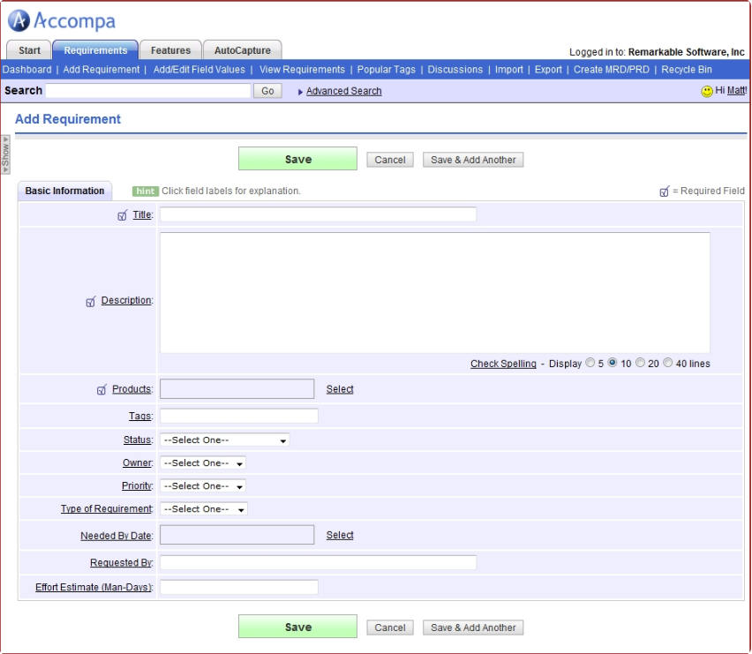

c-

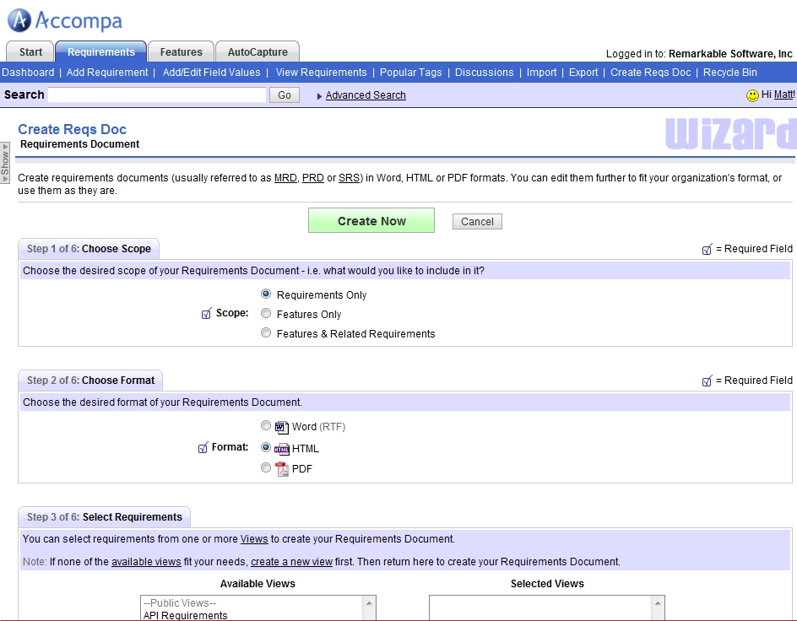

d-

2-Design stage using Animated Software Design (VISME)



3-Development using Adobe Edge Inspect : which allows the developer to his web site on different devices

4-Testing using soapTest

a-Right-click the interface and select Generate SOAP Mock Service

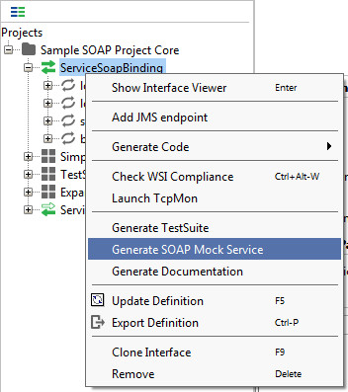

b- In the Generate Mock Service dialog, you can specify the desired parameters for the new mock service. Leave the default settings for now and click OK.

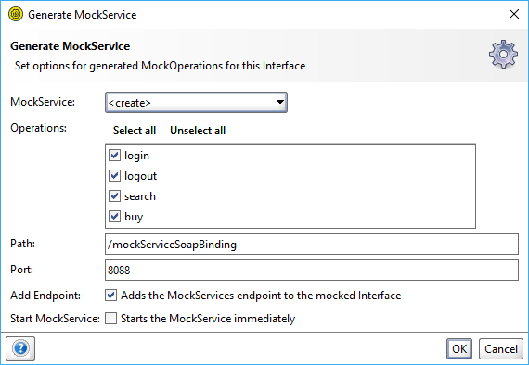

C- Enter the name of your mock service and click OK

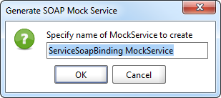

d- The mock service will now be generated successfully:

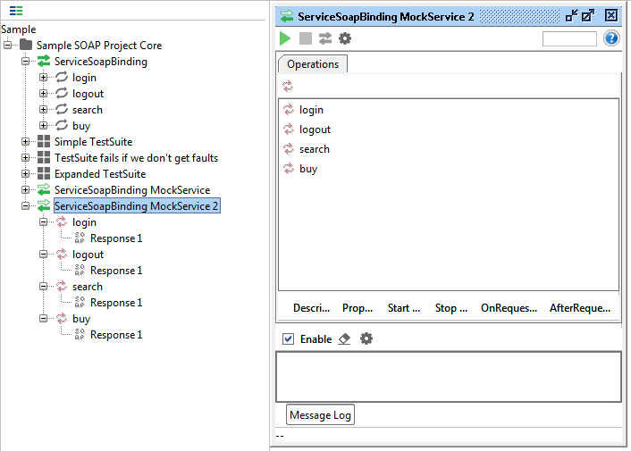

e- You can then choose how to respond to the request and choose how to dispatch (send out) different responses.

-The sample project already contains the ServiceSoapBinding mock service. Let's look at how the mock service works:

1- Open it by double-clicking ServiceSoapBinding MockService:

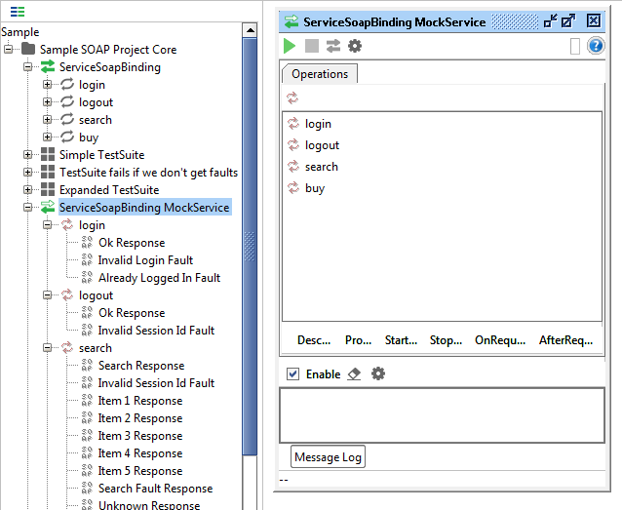

2- Browse through different operations in the mock service (login, logout, search, and buy) and see what we do with different requests. As you can see, all the requests are dispatched by using scripts. This is by far the most common way of dispatching, but early on in a project you might just want to create a set of responses and dispatch them in sequence or at random.

To change the dispatch method, use the Dispatch drop-down list:

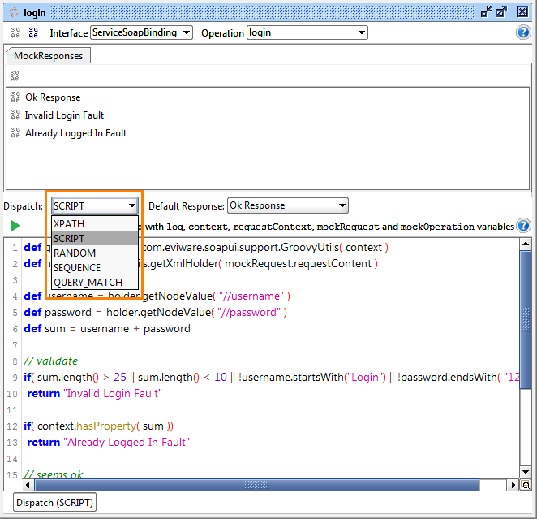

3- To start and stop the mock service, use the buttons on the mock service toolbar:

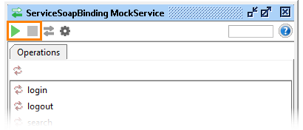

5- Maintenance using Bugzilla:

-Creating a Bug-report in Bugzilla

Step 1) To create a new bug in Bugzilla, visit the home-page of Bugzilla and click on NEW tab from the main menu

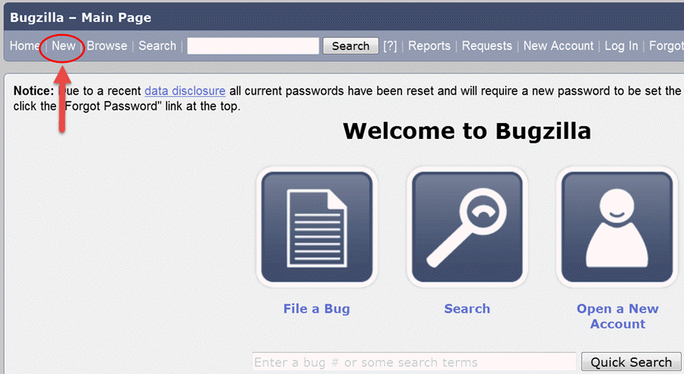

**Step 2)** In the next window

1. Enter Product
2. Enter Component
3. Give Component description
4. Select version,
5. Select severity
6. Select Hardware
7. Select OS
8. Enter Summary
9. Enter Description
10. Attach Attachment
11. Submit

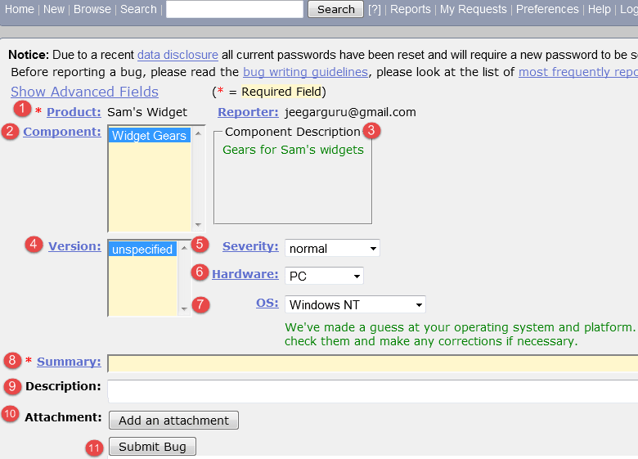

**Step 3) Bug is created** ID# 26320 is assigned to our Bug. You can also add additional information to the assigned bug like URL, keywords, whiteboard, tags, etc. This extra-information is helpful to give more detail about the Bug you have created.

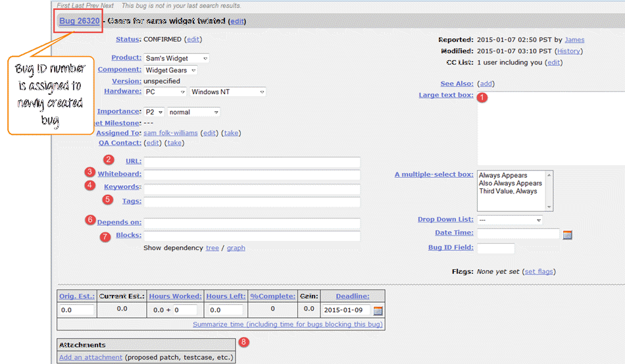

**Step 5)** In the same window if you scroll down further. You can select deadline date and also status of the bug. **Deadline in Bugzilla usually gives the time-limit to resolve the bug in given time frame.**

